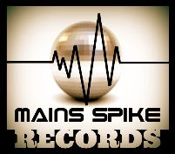
SUPERHOOCH - Red Jacket
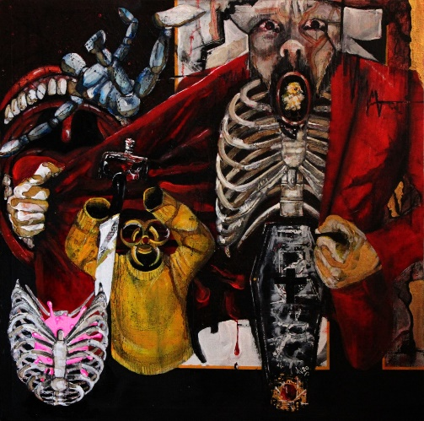
Superhooch release their first full-length album on Mains Spike Records!
Listen here: https://soundcloud.com/superhooch/sets/red-jacket/s-6uQrtK8FDzS

You probably haven’t heard of Superhooch. Why would you have? There’s plenty of so-called ‘rock n’ roll’ bands in the U.K vying for your listening ears. A lot of them are really good too, but I daresay you could list their biggest 3 influences following a cursory listen of their latest single. Same old influences. Same old style. Same old songs.

That’s where this band is different.

Coventry 4-piece Superhooch have a simple mission statement: “If we like it, we write it”. That sentiment is clear with their first full-length offering ‘Red Jacket’; a genre-shifting album about mental health, lofty expectations and cold reality. The music is schizophrenic and encompasses everything from bizarre psychedelia, hypnotic drones, doomy grooves, twisted riffs, funky patterns, brit-pop swagger and trance-inducing vocals.

Rock music doesn’t have to rely on the same old tricks to keep your attention anymore. Try ‘Red Jacket’ on for size.

Superhooch are Chris Worsley (Lead Vocals / Guitar), Johnny Kingham (Guitar / Vocals), Steve Clarke (Bass Guitar / Vocals) & Peanut Marshall (Drums / Vocals).

‘Red Jacket’ is released digitally on Mains Spike Records on 27/06/2020.

FOR BOOKING ENQUIRIES / PRESS INFORMATION:
EMAIL: superhooch@outlook.com
TELEPHONE: 07923813154
RECORD LABEL: Mains Spike Music
WEBSITE: https://www.superhooch.co.uk
HOMETOWN: Coventry, United Kingdom

FOR SOCIAL MEDIA ACCESS:
FACEBOOK: www.facebook.com/superhooch
TWITTER: www.twitter.com/wearesuperhooch

Full EPK Available at https://www.superhooch.co.uk

